Задания школьного этапа Всероссийской олимпиады школьников по английскому языку в 2017/2018 уч. г.

Устный тур

4 класс

Максимальный балл за выполнение заданий устного тура – 10 баллов

Speaking
Talk about the house of your dream. Where would you like your house to be situated: in the city, in the countryside, on the coast, in the mountains, etc. Think of the number of rooms you would like to have. What rooms would there be? What furniture would be in the rooms? Which room would you spend most of the time in?

Задания школьного этапа Всероссийской олимпиады школьников по английскому языку в 2017/2018 уч. г.

Устный тур

5-6 классы

Максимальный балл за выполнение заданий устного тура – 10 баллов

Speaking
Your school has decided to join in a project to help the environment. Look at the pictures and, in pairs, decide which activities you could participate in, giving reasons.
Let’s all help!!!!
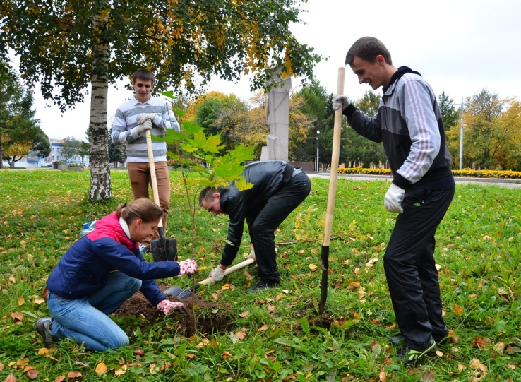  Plant trees / flowers | 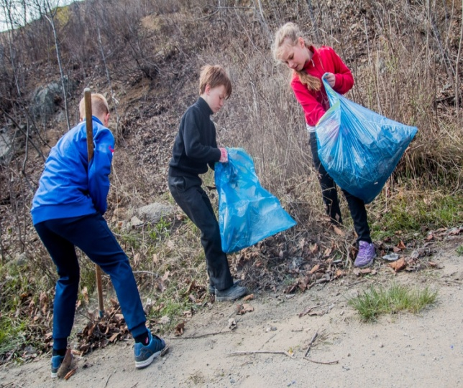  Collect rubbish
  Recycling | 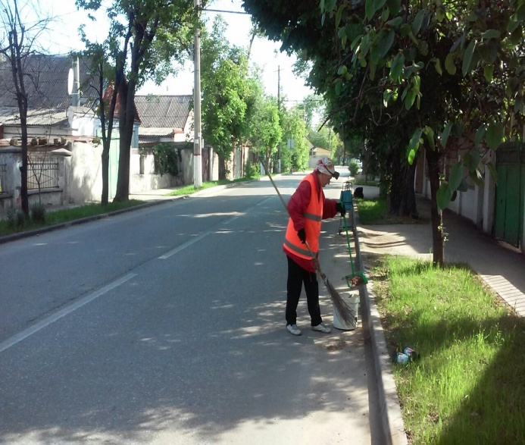  Cleaning streets

7-8

Chess club

Computing & Robotics club

Drama club

Music club
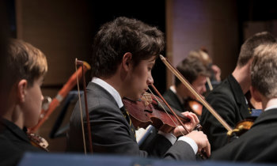

Film-Making club
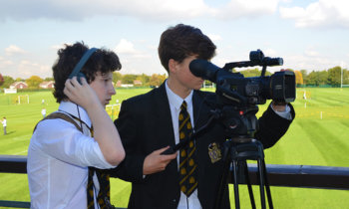
Art club

Debating club

Science club
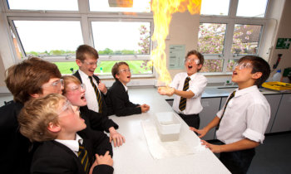
Всероссийская олимпиада школьников по английскому языку.
Школьный этап. 2017-2018 уч. год
Задания для участника 7-8 классы

SPEAKING – 10 баллов

A STUDENT’S CARD

Make a dialogue with a partner on a topic given below. You have 1.5 minutes to prepare (you should not speak to each other). You have 3 minutes to talk.
Your school offers a good choice of clubs to join this year. You and your friend are considering the offer. Look at the photos and discuss which 2 different clubs you would like to join (2 for each of you) and why. Also say what one club (1 for each of you) you wouldn’t like to join. Explain your choice.

Всероссийская олимпиада школьников по английскому языку.
Школьный этап. 2017-2018 уч. год
Задания для участника 7-8 классы

SPEAKING – 10 баллов

A STUDENT’S CARD

Make a dialogue with a partner on a topic given below. You have 1.5 minutes to prepare (you should not speak to each other). You have 3 minutes to talk.
Your school offers a good choice of clubs to join this year. You and your friend are considering the offer. Look at the photos and discuss which 2 different clubs you would like to join (2 for each of you) and why. Also say what one club (1 for each of you) you wouldn’t like to join. Explain your choice.

